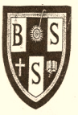
BLANTYRE SECONDARY SCHOOL CLUSTER

2026 JCE MOCK EXAMINATIONS

CHEMISTRY
(100 marks)
Subject Number: J038
Section A (20 marks)
- A
- B
- B
- C
- C
- C
- C
- B
- B
- C
- A
- C
- B
- C
- A
- A
- B
- C
- D
- A

Section B (50 marks)
Answer all questions in this section in the spaces provided
- a. Differentiate between a derived quantity from a basic quantity
- Basic quantity are quantities that are not defined or expressed by other quantities while derived quantities, these are quantities that are defined or expressed by basic quantities
(2 marks)
b. Why are most of the apparatus in chemistry laboratories made of glass?
- Because it is chemically inert, transparent, heat – resistant, resistant to corrosion and easy to clean
(2 marks)
- a. Name two importance of chemistry in everyday life.
- Processing crude oil
- Manufacturing of soap and other detergents used in washing clothes
- Manufacturing of drugs such as Panadol
- It is applied in cooking especially in mixing ingredients (making a cup of tea and preparation of nsima)
- Testing and release of new drugs into the market
- Manufacturing of plastics, fertilizers, insecticides, cement, fabrics
(2 marks)
b. What is the difference between a compound and a mixture?
- The substances in a mixture can be separated by physical method while the substances in a compound cannot be separated by physical methods
- The properties of a mixture are the average of the properties of the substances in it while the properties of a compound are different from the properties of the substances which made it
- The substances that make the mixture need not to be in fixed proportions while that of a compound are in fixed proportions.
- Mixtures are formed by physical methods and no new substance is formed while compound is formed by a chemical method and a new substance is formed.
- No energy is liberated out or absorbed during the formation of the mixture while energy is liberated or absorbed during the formation of the compound
(2 marks)
- a. State the three subatomic particles of an atoms.
- Electrons
- Protons
- Neutrons
(3 marks)
b. Give three ways in which atoms attain stability.
- Losing electrons
- Gaining electrons
- Sharing electrons
(3 marks)

- An element is represented as: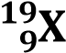. Use it to answer questions that follow:
  - Draw the structure of the atom X
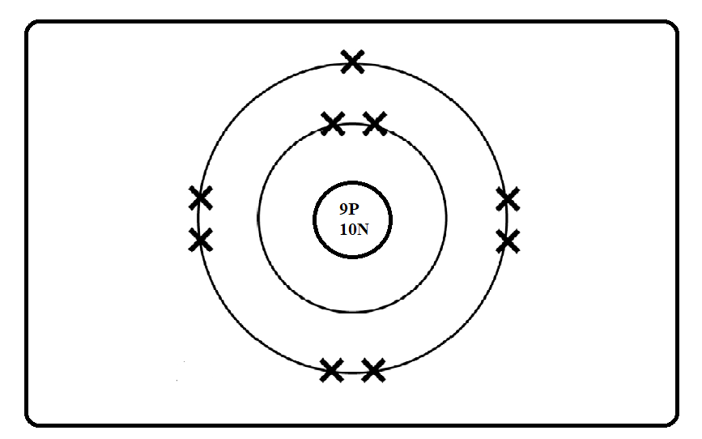
(4 marks)
  - To which group of the periodic table does an atom X belong?
- Group 7 (1 marks)
  - Calculate the number of neutrons of atom X
$$Number of nuetrons=Mass number-Atomic number$$
$$Number of nuetrons=19-9$$
$$Number of nuetrons=10$$
(2 marks)
- The figure below shows a chemical bonding between sodium and chlorine
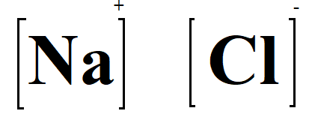
- Name the type of bonding shown above
- Ionic bonding (1 mark)
- Give a reason for your answer.
- Because of the presence of ions after Na has reacted with Cl. Na has lost 1 electron and Chlorine has gained 1 electron also (2 marks)
- Explain how bond mentioned in 25 (a) is formed.
- Ionic bonding involves gaining and losing of electrons among the elements involved in the bonding process. Na has lost the electron an electron which has been gained by Cl (2 marks)
- Magnesium reacts with oxygen gas (O₂) in a reaction below
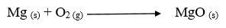
  - Balance the equation above
(2 marks)
  - What does (s) and (g) mean in an equation above?
s: Solid
g: Gas (2 marks)
  - If 60g of Mg was used what would be the mass of MgO produced. (RAM: Mg = 24. O =16)
$$2 moles of Mg produce 2 moles of MgO$$
$$Thus the mole ratio of Mg to MgO is 1:1$$
$$molar masses:Mg=24 and MgO=24+16=40$$
$$24=60 g$$
$$40=X$$
$$X=\frac{40 ×60g}{24}$$
$$X= \frac{2 400g}{24}$$
$$X=100 g$$

(4 marks)
- a. Define Organic Compound
- Organic compounds are chemical compounds that contains carbon atoms usually bonded to hydrogen and sometimes other elements like oxygen, nitrogen, or sulphur (1 mark)
b. Write the general formula for alkenes
- C_{n}H_{2n} (1 mark)
c. List two uses of alkenes
- Manufacture of plastics
- Artificial ripening of fruits such as Mangoes, bananas (2 marks)
d. Name the compound CH₃ (CH₂)₂CH₃
- Butane (1 mark)

- a. Draw the structure of C₃H₆
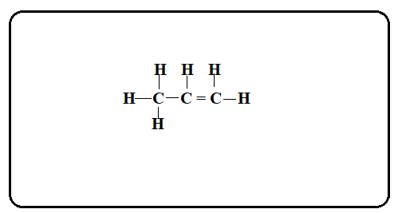
(3 marks)
b. State two ways of determining the strength of an acid.
- Measuring pH using the pH meter
- Using conductivity method (2 marks)
- a. List two advantages of local indicators in identifying acid and bases.
- Environmentally friendly as they are biodegradable
- It is cheap, they can be found locally
- Suitable for simple of informal experiments (2 marks)
b. Element X contains 90% of ¹⁶X, and 10% of ¹⁸X. Calculate the Relative Atomic Mass of X.
Calculate the mass of ¹⁶X
$mass of$¹⁶X = $\frac{90 ×16}{100}$
$mass of$¹⁶X = $\frac{1440}{100}$
$mass of$¹⁶X = 14.4

Calculate the mass of ¹⁸X
$mass of$¹⁸X = $\frac{10 ×18}{100}$
$mass of$¹⁸X = $\frac{180}{100}$
$mass of$¹⁸X = 1. 8
Relative Atomic mass of X = Mass of ¹⁶X + mass of ¹⁸X
Relative Atomic mass of X = 14. 4 + 1.8
Relative Atomic mass of X = 16.2 amu
(4 marks)
Section C (30 marks)
Answer all questions in this section in the spaces provided.
- a. Describe an experiment that can be done to find out if a given gas is oxygen.
- Presence of Oxygen can be confirmed by using glowing – splint test
- Bring a glowing – splint at the mouth of the gas jar that contains the gas we want to test
- If the glowing – splint reignites and burns brightly, then the given gas is Oxygen
- If the glowing – splint goes off the gas is not Oxygen
- Because Oxygen is the only gas that supports combustion
(5 marks)
b. Briefly describe an experiment that could be done to distinguish pentane from pentene
- Pentane and pentene can be distinguished by using bromine test
- Add 10 cm³ of pentane in a test tube and label it properly
- Add 10 cm³ of pentene in a test tube and label it properly
- Add few drops of bromine solution in each test tube
- Observe the colour change of bromine in each test tube
- In a test tube where we have pentane colour will not change showing no reaction with bromine while in the test tube where we have pentene the colour changed to colourless showing an indication of reaction
(5 marks)

- a. Explain any two applications of neutralisation reaction.
- Tooth paste for mouth cleaning has alkalis which neutralises the acid which causes teeth decay
- Excess acids in soils can be neutralised by frequent addition of calcium oxide (quick lime) or calcium hydroxide (slaked lime) in the soil
- Drinking milk to neutralize excess hydrochloric acid in the stomach
- Applying an alkali on the place where one has been bitten by an insect for example a bee relieves pain by neutralizing methanoic acid injected by the insect
(4 marks)
b. Explain clearly how you can produce a local indicator using tomatoes leaves.
- Crush the tomato leaves in a mortar using a pestle
- Add a little amount of ethanol
- Grind the leaves until you get enough extract of the leaves used
- Filter the liquid into a beaker (note the colour of the filtrate)
- Add a few drops of the indicator into two test tubes, one with an acid and the other one with a base (alkali)
- Note and record the colour changes
- Now your local indicator is ready
(6 marks)

- Describe how you can graduate a thermometer.
Material
An unmarked liquid – in – glass thermometer, pure crushed ice and distilled water, a beaker, heat source, a ruler, a marker
- Fill the beaker with crushed ice and add some amount of distilled water
- Place the bulb of the unmarked thermometer into the water – ice mixture but it should not touch the bottom or sides of the beaker
- Wait several minutes for the liquid column to stabilize at its lowest point, mark the level of the liquid on the glass stem as 0ºC
- Heat the distilled water using the source of heat and the beaker until the water boils
- Place the thermometer’s bulb and the stem into the boiling water make sure that it should not touch the bottom or the sides of the beaker
- Wait for some minutes until the liquid column stops rising and stabilizes
- Mark the exact level of the liquid on the glass stem and label it 100 ºC
- Make 100 equal division from 0ºC to 100ºC and mark it properly
(10 marks)

NB: This paper contains 9 printed pages.

